

Requirements Specifications, System Structure,
and Development Phase Plan
Deliverable II
Abstract
This deliverable translates the Lost & Found Application for Campus proposal from Deliverable I into a complete requirements specification (Deliverable II). It defines the system scope and stakeholders, the system structure and its subsystems, the functional and nonfunctional requirements, the user and system interfaces, representative user stories, and a three-phase development plan that sequences the work by criticality. A requirements traceability matrix ties each requirement to the subsystem, phase, and verification approach that will confirm it is met.
Team Falcons
Waleed Mirza, Venkata Sai Anirudh Naidu Mamidi, Sai Sathvika Potluri, Sai Asritha Thati
University of North Texas (UNT)
CSCE 5430, Software Engineering, Fall 2026

Contents
1. Document Purpose
2. System Scope and Stakeholders
3. System Structure
4. Requirements Conventions
5. Functional Requirements
6. Nonfunctional Requirements
7. Interface Requirements
8. User Stories and Acceptance Criteria
9. Three Phase Development Plan
10. Requirements Traceability
11. Member Contribution Table

1. Document Purpose
This report translates the Lost & Found for Campus proposal into requirements that the team can design, implement, and test. It defines the system scope and stakeholders, the system structure, the functional and nonfunctional requirements, the user and system interfaces, representative user stories, and the work assigned to three development phases. Every requirement in this document describes intended system behavior; none of it describes work that has already been built.
The planned system uses a React client, a Node.js and Express REST API, and MongoDB, consistent with the technology stack proposed in Deliverable I. Email notifications and a Leaflet map using OpenStreetMap tiles support the core workflow. The first development phase must support account creation, listing, searching, matching, claiming, and resolving items end to end. Messaging, moderation, the map view, and analytics are layered on in later phases once their dependencies are in place, mirroring the module breakdown from the original proposal while sequencing the work realistically across the semester.

2. System Scope and Stakeholders

2.1 Project Scope
The application provides one campus wide platform for reporting and recovering lost property. A visitor may browse public listings without an account. A verified UNT user may create listings, receive match suggestions, submit or review claims, and coordinate a return after a claim is approved. Campus staff and administrators may moderate reported content and review operational statistics.
The system does not verify legal ownership of an item, guarantee that a suggested match is correct, track a person's live location, process payments, or replace a police report. The person who posted the Found listing decides whether to approve a claim. Moderators may review reported content and recorded evidence, but they do not make legal ownership determinations.

2.2 Stakeholders and Roles
Table 1 lists the stakeholder groups the system serves and summarizes each group's interest in the platform. These groups are consistent with the stakeholders identified in Deliverable I, refined here into the specific roles the system will enforce.
Stakeholder | Interest in the System
Visitor | Browses and searches active public listings without needing an account.
Registered user | Creates listings, receives match suggestions, submits claims, reviews claims on listings they own, and uses approved claim messaging.
Moderator or campus staff | Reviews reported content, hides or restores listings and messages, and records a reason for each moderation action.
Administrator | Manages moderator accounts and item categories, and reviews audit records and system analytics.
Campus Lost & Found office | Uses aggregate information about unresolved items, resolution rates, common categories, and campus locations.
Table 1. Stakeholder groups and their interest in the system.

2.3 Scope Priorities
Requirements in this document use a Must or Should priority. Must requirements define the usable end to end workflow and the required data protections; the system is not viable for release without them. Should requirements add supporting capabilities that complete the experience but may be simplified or deferred if a documented schedule risk occurs, consistent with the core versus stretch feature split from the Deliverable I risk management plan. Table 2 summarizes this convention.
Priority | Meaning
Must | Required for the planned system to provide its core workflow or to protect its data.
Should | Expected for a complete release but may be simplified or deferred if a documented schedule risk occurs.
Table 2. Priority convention used throughout this specification.
This specification refines the Deliverable I proposal by treating matching and claims as part of the required core workflow rather than as optional extensions, while scheduling messaging, the map view, moderation, and analytics for later phases once the core workflow is stable.

3. System Structure

3.1 Architecture Overview
The system follows the same three-tier web architecture proposed in Deliverable I, expanded here to show every subsystem the requirements in this document depend on. The browser presents the user interface for every role. The Express API performs validation, authorization, listing management, matching, claim processing, notifications, messaging, moderation, and analytics. MongoDB stores all application data. The API sends transactional email through an external provider, and the browser requests public map tiles directly through Leaflet so that no private claim evidence or account data passes through the mapping service. Figure 1 shows this structure.
Every external dependency in Figure 1 keeps the zero-budget approach proposed in Deliverable I: MongoDB Atlas is used on its free tier, Leaflet with OpenStreetMap requires no paid API key, and the client and API are intended for deployment to a free tier host such as Render or Vercel. Email delivery uses whichever authenticated provider offers a free or no cost plan, for example a free SMTP account, Mailtrap, or Ethereal during development and testing, consistent with the fallback options identified in the Deliverable I risk management plan. Communication interface requirement IF-COM-03 also avoids the cost and complexity of a hosted real time messaging service by using periodic polling instead of a persistent socket connection, which keeps the messaging feature implementable within the same free tier hosting plan.
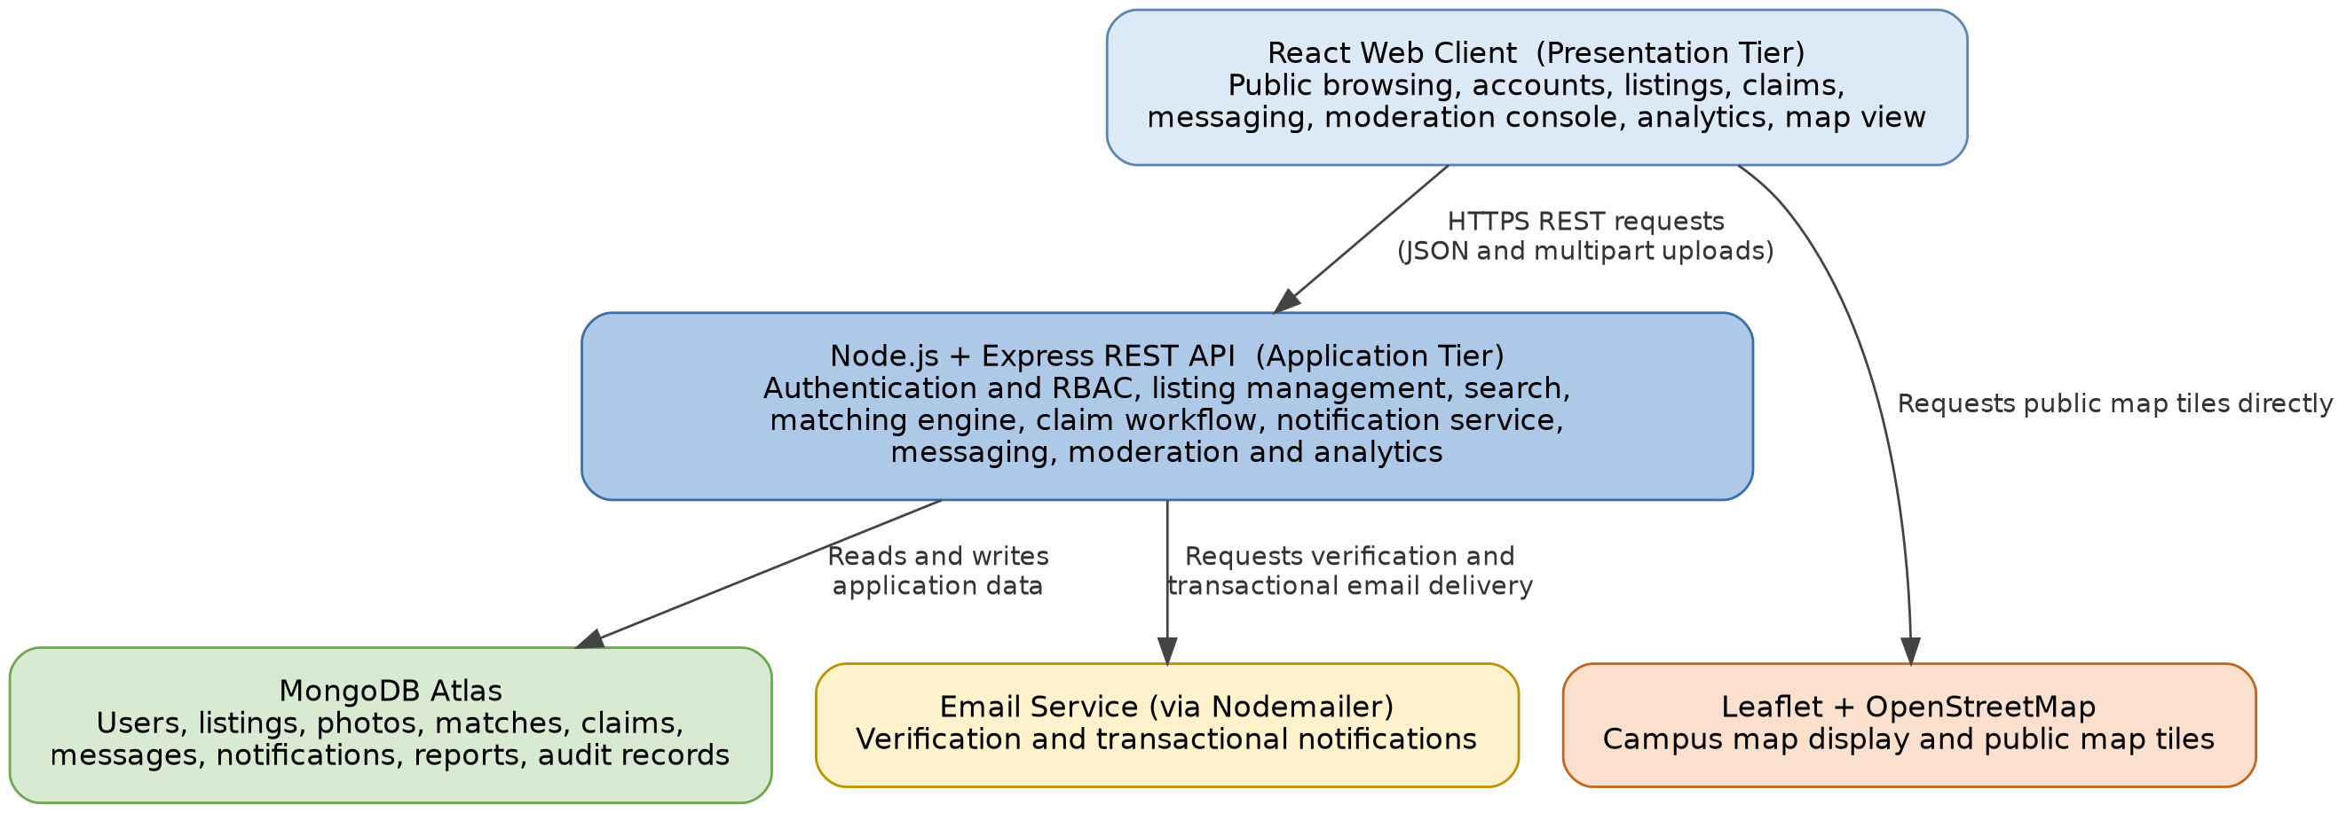
Figure 1. System structure for Lost & Found for Campus, showing the presentation tier, the application tier and its internal modules, and the data and external service tier.

3.2 Subsystem Responsibilities
Table 3 describes the responsibility of each subsystem shown in Figure 1. The first eight rows are internal modules of the Express API; the last four rows are the external data, service, and hosting tier.
Subsystem | Responsibility
React web client | Presents public browsing, account, listing, claim, messaging, moderation, and analytics views. It calls the API for application data and requests public map tiles directly for the map view.
Authentication and RBAC | Registers campus users, verifies approved email domains, creates authenticated sessions, and enforces User, Moderator, and Administrator permissions on every protected route.
Listing management | Creates and maintains Lost & Found listings, photos, status changes, ownership, and resolution records.
Search and map | Supports keyword search, filters, pagination, building or zone selection, and approximate map markers.
Matching engine | Compares active Lost listings with active Found listings using category, date, location, and keyword evidence, and returns ranked suggestions rather than ownership decisions.
Claim workflow | Collects private evidence, records claim decisions, prevents more than one approved claim per listing, records the approved participants, and records return and resolution.
Notification service | Creates in app notifications and requests optional transactional email delivery. Email failure does not reverse the underlying application action.
Messaging | Stores asynchronous messages tied to one approved claim. Access is limited to the claimant, the listing owner, and an authorized moderator reviewing a linked report.
Moderation and analytics | Processes reports, hides or restores content, records administrative actions, and aggregates non private operational statistics for staff.
MongoDB Atlas (free tier) | Stores users, listings, photos or photo references, match suggestions, claims, messages, notifications, reports, and audit events.
Email service | Sends verification and transactional messages through an authenticated email provider on a free or no cost plan, such as a free SMTP account, Mailtrap, or Ethereal.
Leaflet and OpenStreetMap | Displays the campus map and public map tiles. The application stores only a selected building or zone and an optional approximate pin, never a precise live location.
Hosting platform (free tier) | Render or Vercel hosts the deployed client and API for development and demonstration, consistent with the hosting approach proposed in Deliverable I.
Table 3. Subsystem responsibilities.

3.3 Main Data Flow
The numbered flow below traces a typical request through the system, from the browser to the data and service tier and back.
- The browser sends an authenticated or public request to the REST API over HTTPS.
- The API validates the request, checks authorization, performs the requested business operation, and reads from or writes to MongoDB.
- Creating or materially updating a listing can trigger a match calculation. A qualifying suggestion creates an in app notification and may request an email notification.
- Approving a claim closes competing pending claims and records the selected claimant and listing owner. The Phase 3 messaging service then makes one private thread available to those two participants.
- The browser requests public map tiles directly from the map service. Private application data always remains behind the API's authorization checks and never reaches the mapping or email providers.

4. Requirements Conventions
Each requirement in Sections 5 through 7 has a stable identifier made up of a category prefix, a short area code, and a two-digit sequence number, for example FR-AUTH-01. The word shall indicates mandatory planned behavior. Priority indicates implementation criticality using the convention from Table 2. Phase identifies the earliest development phase, defined in Section 9, in which the requirement is expected to be complete. Phase assignments may change only through a documented team decision that preserves the Phase 1 end to end core workflow described in Section 9.1.

5. Functional Requirements
The functional requirements below are grouped by the seven capability areas introduced in Deliverable I: accounts and access control, listings, browsing and search, matching, claims, notifications and messaging, and moderation and analytics.

5.1 Accounts and Access Control
These requirements implement the role-based access control module from Deliverable I.
ID | Requirement | Priority | Phase
FR-AUTH-01 | The system shall allow registration with an @my.unt.edu or @unt.edu email address and shall require email verification before a user can create a listing or submit a claim. | Must | 1
FR-AUTH-02 | A verified user shall be able to sign in, sign out, and request a time limited password reset link without exposing whether another email address has an account. | Must | 1
FR-AUTH-03 | The API shall enforce role permissions for every protected operation. Users may manage their own listings and claims. Moderators may review reports and hide or restore reported content. Administrators may also manage moderator roles, item categories, audit records, and aggregate analytics. | Must | 1
Table 4. Accounts and access control requirements.

5.2 Listings
These requirements implement the core listing workflow proposed in Deliverable I.
ID | Requirement | Priority | Phase
FR-LIST-01 | A verified user shall be able to create a Lost or Found listing with a title, category, public description, date, campus building or zone, and item status. | Must | 1
FR-LIST-02 | A listing shall accept up to three JPEG, PNG, or WebP images of no more than 5 megabytes each. A Found listing shall include at least one image; a Lost listing may omit images when the owner does not have one. | Must | 1
FR-LIST-03 | The owner shall be able to edit or soft delete an Active listing. Other ordinary users shall not be able to modify that listing. | Must | 1
FR-LIST-04 | A Found listing may store private identifying details that are excluded from public views, search results, and match explanations. | Must | 1
Table 5. Listing requirements.

5.3 Browsing, Search, and Map
These requirements implement the search and filter workflow and the interactive campus map view proposed in Deliverable I.
ID | Requirement | Priority | Phase
FR-SRCH-01 | A visitor shall be able to browse Active public listings without signing in and search by title, description, category, brand, color, or keyword. | Must | 1
FR-SRCH-02 | A visitor shall be able to filter listings by Lost or Found type, category, campus building or zone, and date range, with no more than 20 results returned on one page. | Must | 1
FR-SRCH-03 | The system shall provide a campus map that plots listings by a selected building, zone, or approximate pin and does not expose a user's live or precise location. | Should | 3
Table 6. Browsing, search, and map requirements.

5.4 Matching
These requirements implement the automated matching engine proposed in Deliverable I, including the scoring rule the engine applies.
ID | Requirement | Priority | Phase
FR-MATCH-01 | The system shall compare each Active Lost listing with Active Found listings using category, date proximity, campus location, and public keyword similarity. | Must | 2
FR-MATCH-02 | A candidate match shall receive 35 points for the same category; 25 points when the dates are within one day, 15 points within seven days, and 0 points otherwise; 20 points for the same building, 10 points for the same campus zone, and 0 points otherwise; and 20 points for at least three shared normalized public keywords, 10 points for one or two, and 0 points for none. Suggestions scoring at least 65 points shall be ranked from highest to lowest and shall display their contributing factors. | Must | 2
Table 7. Matching engine requirements.

5.5 Claims and Resolution
These requirements implement the claim verification workflow proposed in Deliverable I, including the safeguard against a false or fraudulent claim succeeding. Figure 2 carries forward the claim verification workflow diagram from Deliverable I, annotated here with the specific requirement each step satisfies.
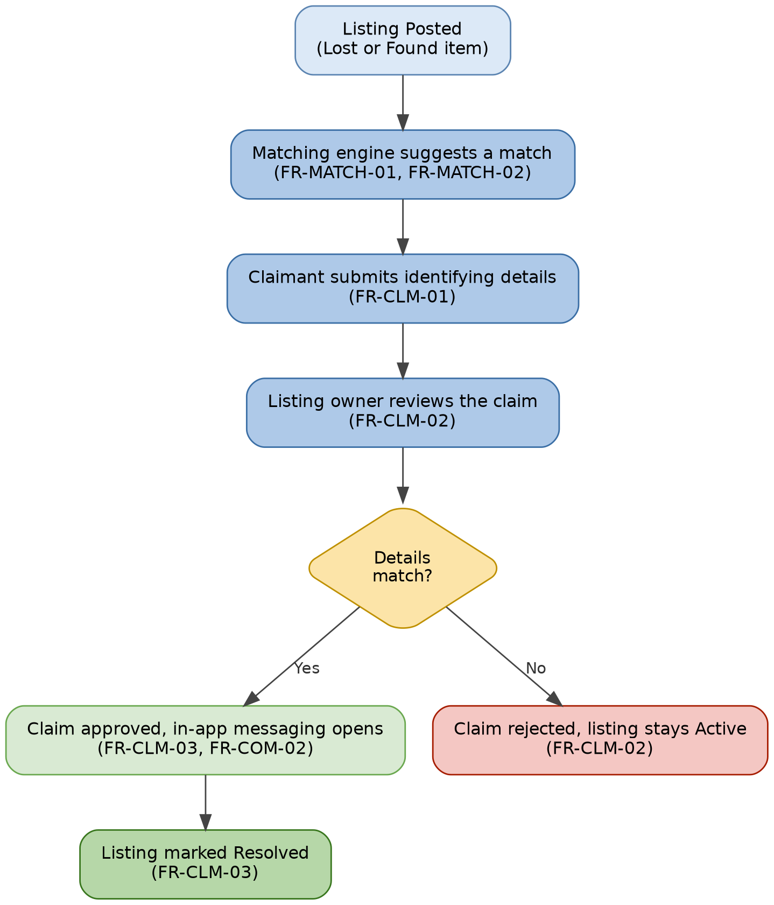
Figure 2. Claim verification workflow, carried forward from Deliverable I and annotated with requirement IDs.
ID | Requirement | Priority | Phase
FR-CLM-01 | A verified user other than the listing owner shall be able to submit a claim for an Active Found listing with an ownership explanation and at least two private identifying details, such as a serial number suffix, a unique mark, or nonpublic contents. | Must | 2
FR-CLM-02 | The system may retain multiple Pending claims for one listing, but the owner shall be able to approve only one claim, or reject a claim, after reviewing its private evidence. | Must | 2
FR-CLM-03 | Approving a claim shall change the listing status to Pending Return, close competing Pending claims, and allow the owner to mark the item Resolved after the handoff is complete. | Must | 2
Table 8. Claim and resolution requirements.

5.6 Notifications and Messaging
These requirements implement the notification service and the in-app messaging module proposed in Deliverable I.
ID | Requirement | Priority | Phase
FR-COM-01 | The system shall create an in-app notification for a potential match, a new claim, a claim decision, an approved claim message, a resolution, or a moderation action. A verified user may enable or disable optional email notifications. A failed email shall be logged and retried once, and shall never reverse the underlying application action. | Should | 2
FR-COM-02 | After a claim is approved, the claimant and the listing owner shall be able to exchange text messages in one private thread. A moderator may access that thread only while reviewing a report associated with it, and the system shall record that access in the audit log. | Must | 3
Table 9. Notification and messaging requirements.

5.7 Moderation, Administration, and Analytics
These requirements implement the admin and analytics dashboard proposed in Deliverable I, together with the moderation actions that keep the platform safe.
ID | Requirement | Priority | Phase
FR-ADM-01 | A signed in user shall be able to report a listing or a message, and a moderator shall be able to review the report and hide or restore the reported content after recording a reason. | Should | 3
FR-ADM-02 | An administrator shall be able to manage moderator accounts and item categories, and the system shall record every role change and moderation action in an audit log. | Should | 3
FR-ADM-03 | An authorized dashboard shall show aggregate listing counts, resolution rate, average resolution time, common categories, and campus hotspot locations, without displaying private evidence or message contents. | Should | 3
Table 10. Moderation, administration, and analytics requirements.

6. Nonfunctional Requirements
The nonfunctional requirements below cover the quality attributes that matter most for a public facing campus service that stores private claim evidence: performance, security and privacy, reliability, usability, and maintainability.

6.1 Performance and Capacity
ID | Requirement | Priority
NFR-PERF-01 | Under a test load of up to 50 concurrent users, at least 95 percent of ordinary API requests shall complete within two seconds, excluding image upload and external email delivery. | Must
NFR-PERF-02 | Search shall return the first results page within three seconds for a test dataset of 5,000 listings. | Must
NFR-PERF-03 | Search results shall use server-side pagination and shall return no more than 20 listings per page. | Must
Table 11. Performance and capacity requirements.

6.2 Security and Privacy
ID | Requirement | Priority
NFR-SEC-01 | Production traffic shall use HTTPS, and every protected request shall require an authenticated session. | Must
NFR-SEC-02 | Passwords shall be hashed with bcrypt and shall never be stored or logged in plain text. | Must
NFR-SEC-03 | The server shall validate request fields, enforce upload type and size limits, and rate limit sign in, password reset, claim, and messaging requests. | Must
NFR-PRIV-01 | Public responses and application logs shall not expose passwords, tokens, email addresses, private listing details, claim evidence, or message contents. | Must
NFR-PRIV-02 | An account deletion request shall disable access immediately and shall remove or de-identify profile data within 30 days. Resolved listings, claims, messages, and associated images shall be deleted after 90 days; noncontent audit records may be retained for one year. Data related to an unresolved moderation case may be retained until the case closes. | Should
Table 12. Security and privacy requirements.

6.3 Reliability and Availability
ID | Requirement | Priority
NFR-REL-01 | The system shall confirm a database write before reporting that a listing, claim, message, or status change succeeded. | Must
NFR-REL-02 | During a continuous seven-day test period, core endpoints shall be available for at least 99 percent of scheduled uptime, excluding announced maintenance. An email or map failure shall not interrupt listing, search, claim, or in app notification workflows. | Must
Table 13. Reliability and availability requirements.

6.4 Usability, Accessibility, and Compatibility
ID | Requirement | Priority
NFR-USA-01 | Forms shall clearly identify required fields, preserve valid values after a validation error, and place a specific error message near the affected field. | Must
NFR-ACC-01 | Registration, sign in, listing, search, claim, and messaging workflows shall satisfy applicable WCAG 2.1 Level AA criteria for keyboard operation, visible focus, form labels, error identification, and use of color. | Must
NFR-COMP-01 | Primary workflows shall support current versions of Chrome, Edge, Firefox, and Safari and shall remain usable from a 360-pixel mobile viewport through desktop sizes. | Should
Table 14. Usability, accessibility, and compatibility requirements.

6.5 Maintainability and Testability
ID | Requirement | Priority
NFR-MNT-01 | The repository README shall document setup steps, required environment variable names, test commands, and deployment steps, without including secret values. | Must
NFR-TST-01 | Automated tests shall cover authorization boundaries and the main successful and unsuccessful listing, matching, claim, and messaging paths. No release shall contain a known failing Must acceptance test. | Must
Table 15. Maintainability and testability requirements.

7. Interface Requirements
This section specifies the user, software, communication, and hardware interfaces the system depends on.

7.1 User Interfaces
ID | Interface Requirement
IF-UI-01 | Public listing pages shall present only public listing data and shall provide sign-in links before any protected action.
IF-UI-02 | The listing form shall support keyboard entry, campus building or zone selection, conditional photo requirements, and a preview before submission.
IF-UI-03 | The claim review page shall separate public listing information from private evidence and shall require confirmation before claim approval.
Table 16. User interface requirements.

7.2 Software Interfaces
ID | Interface Requirement
IF-SW-01 | The React client shall call versioned Express REST endpoints and shall exchange JSON, except when uploading files.
IF-SW-02 | File uploads shall use multipart form data and shall be validated before a permanent file reference is stored.
IF-SW-03 | The API shall be the only application component that directly reads or writes MongoDB application collections.
IF-SW-04 | Leaflet shall display OpenStreetMap tiles with the required attribution, and the application shall store only approximate campus locations.
Table 17. Software interface requirements.

7.3 Communication Interfaces
ID | Interface Requirement
IF-COM-01 | Client and API communication shall use HTTPS with JSON request and response bodies and documented HTTP status codes.
IF-COM-02 | Protected requests shall carry the configured authenticated session credential, and the server shall reject a missing, expired, or unauthorized credential.
IF-COM-03 | Email delivery shall use an authenticated provider. While a message thread is open, the client shall retrieve updates through REST polling no more frequently than once every 15 seconds and shall also provide a manual refresh; the system shall not require a real time socket connection.
Table 18. Communication interface requirements.

7.4 Hardware Interfaces
ID | Interface Requirement
IF-HW-01 | The system shall require no specialized hardware. It shall operate in a supported browser on a desktop computer, laptop, tablet, or phone. A user may select an existing image or use the device camera through the browser's standard file picker. The application does not require continuous GPS access, NFC, or barcode readers.
Table 19. Hardware interface requirements.

8. User Stories and Acceptance Criteria
Table 20 illustrates how a representative sample of the functional requirements above is experienced from each stakeholder's point of view. Each story is written in Given, When, Then form so it can be converted directly into an acceptance test.
ID | User Story | Acceptance Criterion
US-01 | As a visitor, I want to browse active listings so that I can check whether an item has been reported before creating an account. | Given an Active listing, when a visitor searches for its title or category, then the listing appears without exposing private fields.
US-02 | As a student who lost an item, I want to create a Lost listing so that the system can show possible Found matches. | Given a verified user and valid required fields, when the user submits a Lost listing, then it is stored as Active and is available to the matching service.
US-03 | As a person who found an item, I want to record private identifying details so that I can evaluate claims without publishing those details. | Given a Found listing, when a visitor opens it, then the private verification details are absent from the response.
US-04 | As a listing owner, I want ranked match suggestions so that I can review the most likely matches first. | Given qualifying opposite type listings, when matching completes, then suggestions scoring at least 65 are ordered from highest to lowest and show the contributing factors.
US-05 | As a claimant, I want to submit private ownership evidence so that the finder can evaluate my claim. | Given an Active Found listing owned by another user, when the claimant submits an explanation and two private details, then a Pending claim is created.
US-06 | As a finder, I want to approve one claim so that I can coordinate the return with the selected claimant. | Given multiple Pending claims, when one claim is approved, then the listing becomes Pending Return, the other Pending claims close, and the selected participants are recorded for the Phase 3 message thread.
US-07 | As an approved claimant, I want to exchange messages without publishing my contact details so that we can arrange a handoff. | Given an Approved claim, when either participant opens the thread, then only that claimant, the listing owner, and an authorized moderator can read it.
US-08 | As a listing owner, I want to mark a handoff complete so that resolved items leave the active board. | Given a Pending Return listing, when the owner confirms the handoff, then the listing becomes Resolved and disappears from public Active results.
US-09 | As a moderator, I want to review reported content so that harmful or fraudulent content can be hidden with a recorded reason. | Given a valid report, when a moderator hides the content, then it disappears from public views and the action is added to the audit log.
Table 20. Representative user stories and acceptance criteria.

9. Three Phase Development Plan
The project will be implemented as three working increments, matching the incremental approach requested for this deliverable. Each phase ends with a demonstrable build and a review of its assigned requirements. Later phases depend on the data model, authorization, and core listing behavior completed in Phase 1, so requirements are ordered by that dependency as well as by criticality.
These three implementation phases fit inside the semester timeline established by the Gantt chart in Deliverable I (Figure 3): Phase 1 begins during Deliverable 3 (system design, due October 19) and carries into Deliverable 4 (core implementation, due November 9); Phase 2 completes within Deliverable 4; and Phase 3 spans Deliverable 5 (final implementation, testing, and demonstration, due November 30). No new project dates are introduced here, only a finer breakdown of the implementation work already scheduled in Deliverable I.

9.1 Phase 1: Foundation and Core Listings
Working increment: a verified user can create, edit, find, and remove a listing, and public browsing and server-side authorization both work end to end.
- Set up the client, API, database connection, environment configuration, and repository workflow.
- Implement registration, campus email verification, sign in, role checks, and protected API routes (FR-AUTH-01 through FR-AUTH-03).
- Implement listing validation, image restrictions, listing ownership, status handling, public browsing, search, filters, and pagination (FR-LIST-01 through FR-LIST-04, FR-SRCH-01, FR-SRCH-02).
- Test that an ordinary user cannot modify another user's listing or access protected administrative endpoints.
Exit criterion: the end to end create, browse, search, edit, and soft delete workflows pass their Must acceptance tests in the deployed test environment. This phase carries the highest criticality, since every later phase depends on it.

9.2 Phase 2: Matching and Claims
Working increment: the system produces explainable match suggestions, accepts private claims, supports one owner decision per listing, and creates notifications.
- Implement the rules-based match score and store match suggestions together with their contributing factors (FR-MATCH-01, FR-MATCH-02).
- Implement private claim evidence, pending claims, owner decisions, competing claim closure, return confirmation, and resolution (FR-CLM-01 through FR-CLM-03).
- Create in app notifications and optional email delivery. An email failure must not reverse a successful claim or listing action (FR-COM-01).
- Run integration tests across matching, claims, authorization, notifications, and resolution.
Exit criterion: a Lost & Found pair can be matched, claimed, approved, and resolved without exposing private evidence to an unauthorized user. This phase is Must priority, since matching and claim approval are the core value proposition of the platform, with the notification requirement FR-COM-01 carried at Should priority within the phase.

9.3 Phase 3: Communication, Moderation, Map, and Analytics
Working increment: approved participants can coordinate a return through private messaging, and staff can moderate content, view the campus map and analytics dashboard, and review audit records.
- Implement the approved claim message thread, the 15 second polling limit, report linked moderator access, and audit logging (FR-COM-02).
- Add the building or zone map view and an equivalent list-based navigation option (FR-SRCH-03).
- Implement report review, content hiding and restoration, moderator management, audit events, and aggregate analytics (FR-ADM-01 through FR-ADM-03).
- Complete accessibility, cross browser, responsive layout, performance, and end to end release testing.
Exit criterion: the final release passes all Must tests, documents any deferred Should requirement, and can be demonstrated from registration through item resolution and administrative review. Messaging (FR-COM-02) is carried at Must priority because it completes the claim workflow started in Phase 2; the map view and moderation and analytics capabilities are Should priority and are the first candidates to simplify if the team falls behind schedule.

9.4 Phase Assignment Summary
Table 21 summarizes the requirements assigned to each phase and the priority order within that phase, consistent with the detailed phase descriptions above.
Phase | Assigned Requirement IDs | Priority Order Within Phase
Phase 1 | FR-AUTH-01 to FR-AUTH-03; FR-LIST-01 to FR-LIST-04; FR-SRCH-01, FR-SRCH-02; supporting NFR and interface requirements | All Must
Phase 2 | FR-MATCH-01, FR-MATCH-02; FR-CLM-01 to FR-CLM-03; FR-COM-01 | Must, then Should (FR-COM-01)
Phase 3 | FR-SRCH-03; FR-COM-02; FR-ADM-01 to FR-ADM-03 | Must (FR-COM-02), then Should
Table 21. Requirements assigned to each development phase.

9.5 Phase Control and Change Management
The team will track each requirement as To Do, Doing, Stalled, or Done on the shared Trello board, consistent with the board columns established in Deliverable I, and will link implementation work to GitHub issues or pull requests. A requirement is Done only after its code, review, and relevant tests are complete. If schedule risk requires a change, the team will simplify or defer Should requirements first, following the core versus stretch approach from the Deliverable I risk management plan. A Must requirement may be deferred only after the team records the resulting loss of core functionality and obtains course guidance when necessary.

10. Requirements Traceability
Table 22 traces each requirement area to the subsystem that implements it, the phase in which it is delivered, and the approach the team will use to verify it, so that no requirement in Sections 5 through 7 is left without an owner or a test plan.
Requirement Area | Subsystem | Requirement IDs | Phase | Planned Verification
Accounts and access | Authentication and RBAC | FR-AUTH-01 to 03 | 1 | Registration, session, password reset, and authorization tests
Listings | Listing management | FR-LIST-01 to 04 | 1 | Create, upload, edit, deletion, ownership, and privacy tests
Search and map | Search and map | FR-SRCH-01 to 03 | 1, 3 | Browse, search, filter, pagination, privacy, and map tests
Matching | Matching engine | FR-MATCH-01, 02 | 2 | Score fixtures, threshold, ordering, and explanation tests
Claims | Claim workflow | FR-CLM-01 to 03 | 2 | Evidence privacy, decisions, competing claims, and resolution tests
Notifications and messaging | Notification service, Messaging | FR-COM-01, 02 | 2, 3 | Notification events, email failure handling, and thread access tests
Moderation and analytics | Moderation and analytics | FR-ADM-01 to 03 | 3 | Report handling, role, audit, aggregation, and privacy tests
Quality attributes | All subsystems | All NFR and IF requirements | 1 to 3 | Security, performance, accessibility, compatibility, and interface tests
Table 22. Requirements traceability matrix.

11. Member Contribution Table
Work on this deliverable was divided by subsystem ownership established in Deliverable I and was completed evenly across all four team members, as detailed below.
Member Name | Contribution Description | Overall Contribution (%) | Note
Waleed Mirza | Compiled and formatted the Deliverable 2 report, wrote the system scope and stakeholder sections, drafted the authentication and claim workflow requirements, and reviewed the three phase development plan. | 25%
Venkata Sai Anirudh Naidu Mamidi | Wrote the system structure and subsystem descriptions, drafted the matching, notification, and software and communication interface requirements, and compiled the requirements traceability matrix. | 25%
Sai Sathvika Potluri | Drafted the search, map, accessibility, and other nonfunctional requirements, reviewed the consistency of the requirements specifications, and proofread the report. | 25%
Sai Asritha Thati | Drafted the listing and messaging requirements, wrote the user stories and acceptance criteria, reviewed the testing and dependency details in the development plan, and compiled the member contribution table. | 25%
Table 23. Member contribution table for Deliverable 2.
Note: The updated meeting minutes, including the Deliverable 2 review meeting, and the note-deliverable-2 file are submitted directly in the team's GitHub repository, as specified in the assignment instructions.
Repository Link: https://github.com/wmirza1987/csce5430-falcons-lostandfoundapp

